PHASE 2
Design Document

Invigilation Processor – Examiner’s Magnifier
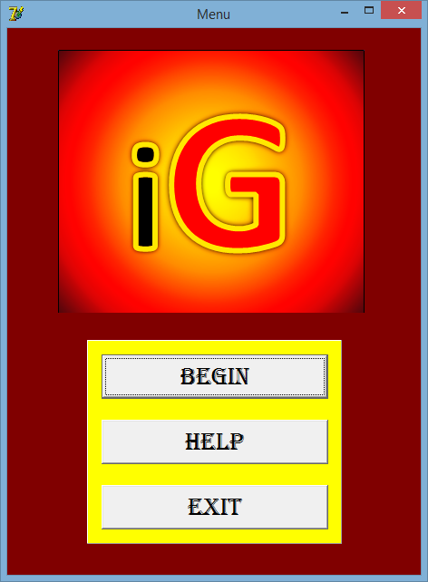

Developed by Tony Guo

Signoffs
Phase | Teacher | Date | Signature
2) Design Document | Mrs. Niebuhr
Table of Contents
1. Summary 3
2. Presentation Layer 4
2.1 GUI Screens 4
3. Business Layer 15
Sequencing 15
5. Database Layer 29
Explanation of data storage 29

1. Summary
Splashscreen Form:
1 Image Logo to start program off.

Menu Form:
3 Buttons to begin Invigilation, get Help or Exit application.

Input Form:
1 Panel to keep track of Inputted Files.
A PageControl Component with the Following Tabs:
- Staff List
3 Listboxes to show Staff, Invigilators and Matric.
ADOQuery and OpenDialog to get path of file.
- Exam Timetable and Set Number of Learners
2 Listboxes to show Exam Timetable and Subjects whose number of learners could not be set.
ADOQuery and OpenDialog to get path of file.
- Important Dates
3 Listboxes to show the dates, the teachers and add teachers to the events.
ADOQuery and OpenDialog to get path of file
- Teacher’s Pictures
1 Listbox to show the teachers.
1 Image to load the images to see them.
ADOQuery and OpenDialog to get path of file.
- Subject List
2 Listboxes to show the teachers to be added and the subjects of each grade.
ADOQuery and OpenDialog to get path of file.
- Grade Managers
1 Listbox to show the staff.
10 Edits to get managers.

Help Form:
1 Tabsheet with a RedOut on all of them to show the help for each form.

Summary Form:
Labels and Edits to display results or calculated data.

Output Form:
Frames to keep track of each teachers hours invigilated.
Labels, listboxes and richedits to display information.

2. Presentation Layer

2.1 GUI Screens



GUI screen: Splash Screen

Description | Start of the program. Look professional and show its app logo.
Security Group | All users. Invigilator manager especially.
Data | None.
Actions | None.

GUI screen: Menu
Description | Welcome menu page. Invigilator can choose what option he would like to go.
Security Group | All users. Invigilator manager especially.
Data | None.
Actions | btnBegin – begins the Invigilation process.  btnHelp – opens up the help manual.  btnExit – exits the program.

GUI screen: Help
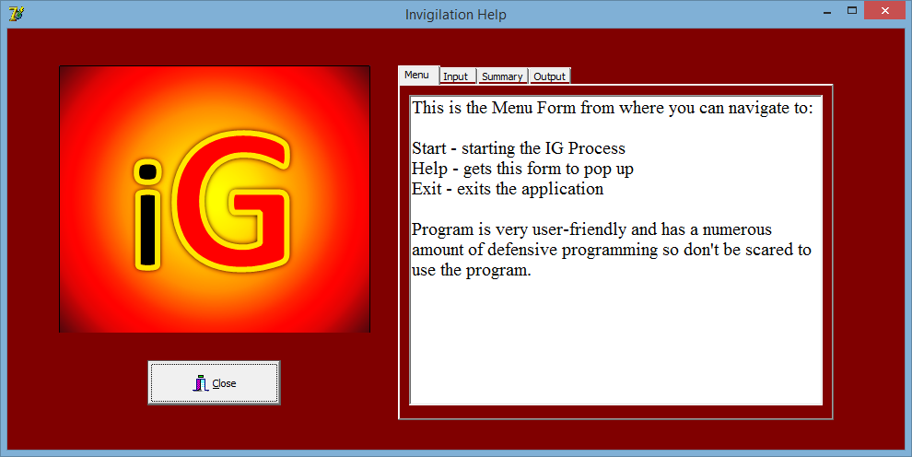
Description | Help Manual on how to use the program.
Security Group | All users. Invigilator manager especially.
Data | None.
Actions | btnClose – closes help manual.

GUI screen: Input : Staff and Student Teachers
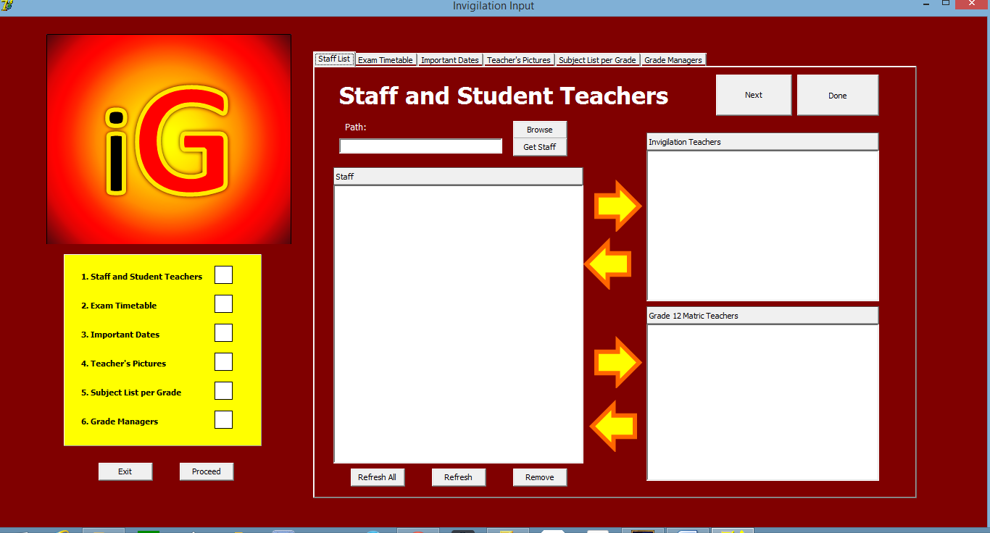
Description | Input staff list into application.
Security Group | All users. Invigilator manager especially.
Data | Path – put file path of Staff 2015.xlsx in.
Actions | imgArrowAdd – add to listbox invigilators or matric teachers  imgArrowRemove – removes from listbox back to staff list

GUI screen: Input : Exam Timetable
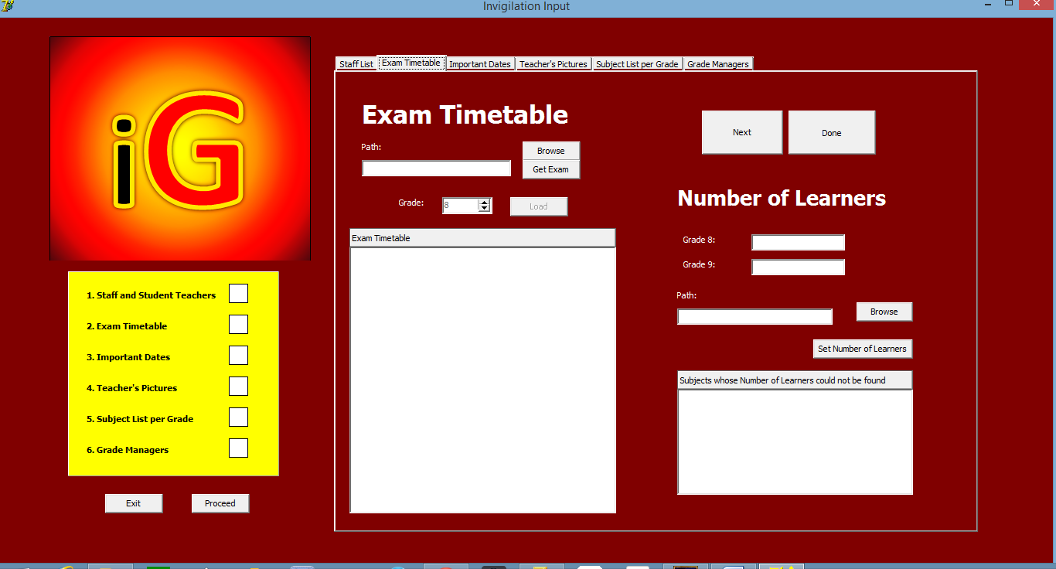
Description | Input Exam Timetable into application, as well as Number of learners writing per subject.
Security Group | All users. Invigilator manager especially.
Data | Path of files to input.  Number of learners in grade 8 and grade 9.
Actions | btnGetExam – gets exam timetable file and loads it into application.  btnSetNumberOfLearners – sets the number of learners writing per subject.

GUI screen: Input : Important Dates
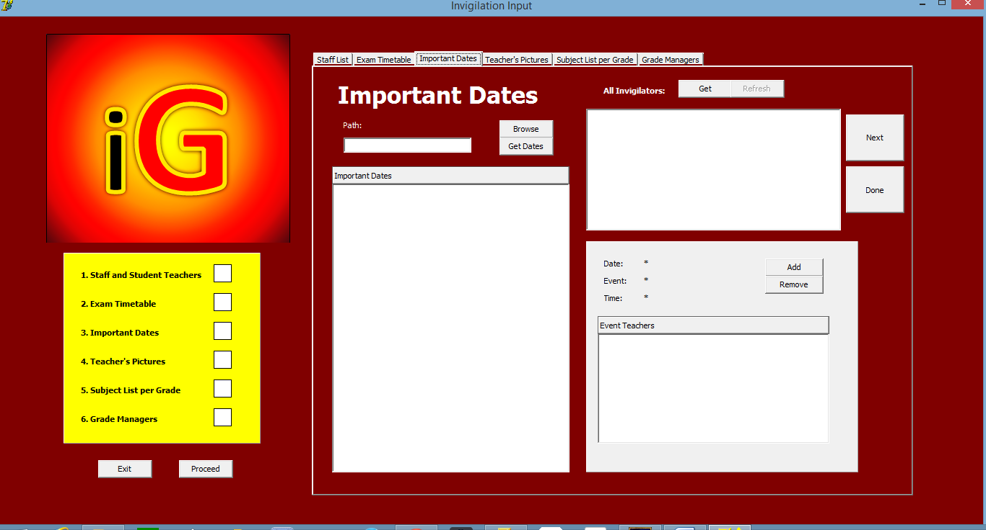
Description | Input important dates during the exam into the application.
Security Group | All users. Invigilator manager especially.
Data | sPath – File path of Important Dates.xlsx.
Actions | btnGetDates – gets the important dates from excel file.  btnAdd – adds teachers to the event  btnRemove – remove teachers from the event

GUI screen: Input: Teacher’s Pictures
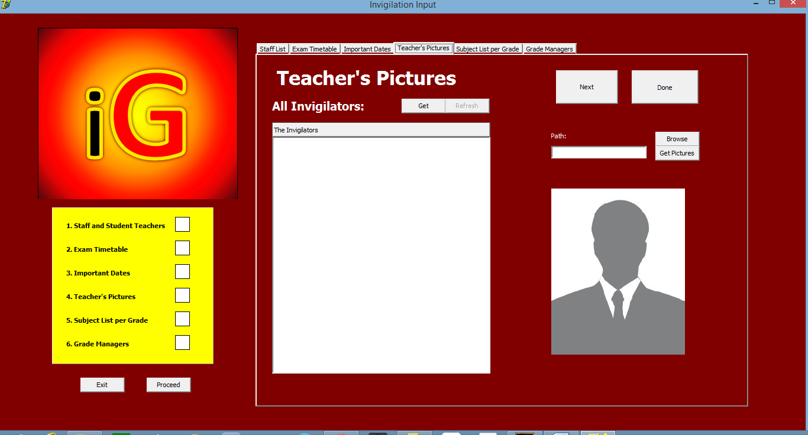
Description | Input teacher’s pictures to the application.
Security Group | All users. Invigilator manager especially.
Data | sPath – folder path of pictures.
Actions | btnGet – gets the Invigilators from Staff List  btnGetPictures – sets the image path of all the invigilators to their classes

GUI screen: Input: Subjects and Their Heads
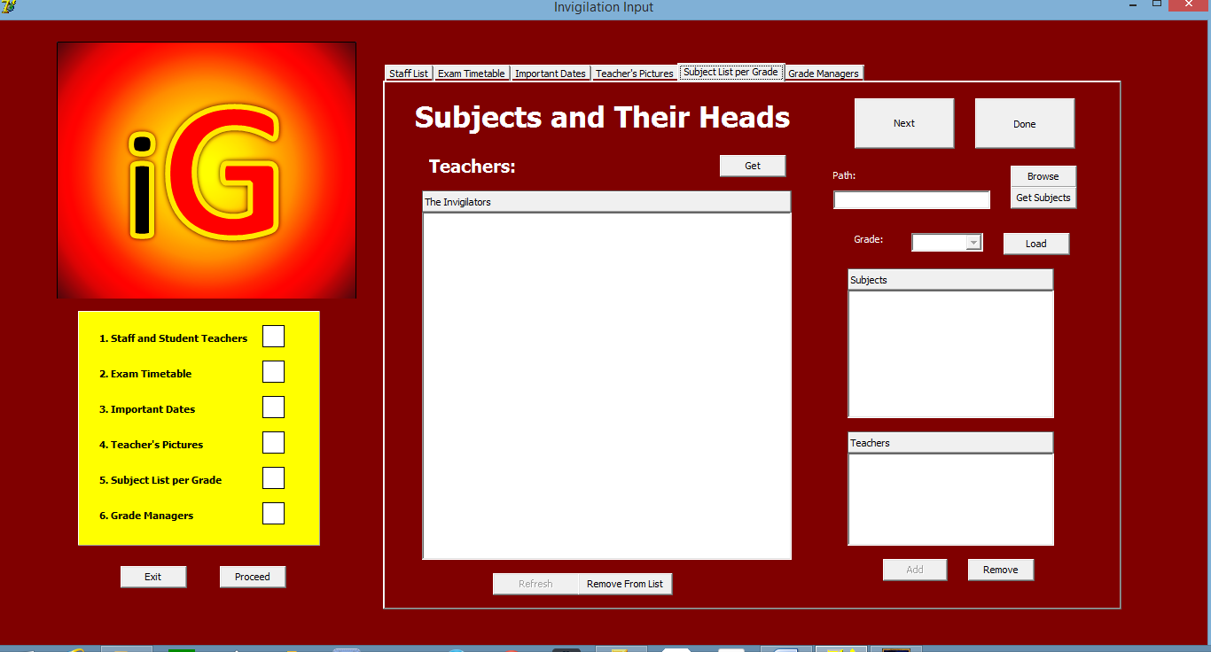
Description | Input subjects’ teachers for each grade.
Security Group | All users. Invigilator manager especially.
Data | sPath – file path of excel file.
Actions | btnGet – gets all the invigilators  btnGetSubjects – gets the subject list for each grade from Subject.xlsx

GUI screen: Input: Grade Managers
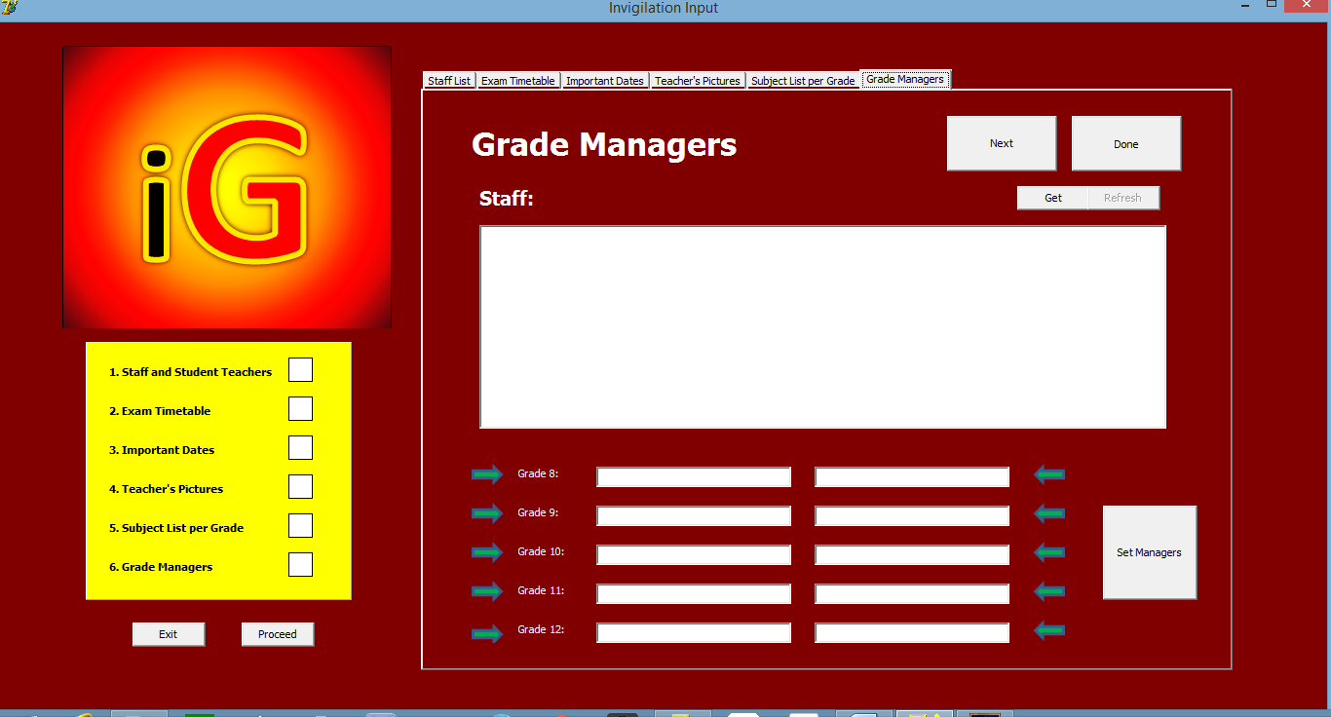
Description | Input Managers for each grade and these managers have to take in all the exam by the end of the day, they, however don’t invigilate.
Security Group | All users. Invigilator manager especially.
Data | None.
Actions | Arrows sets the selected teacher into the editbox.  btnSetManagers – sets the managers for each grade.

GUI screen: Summary
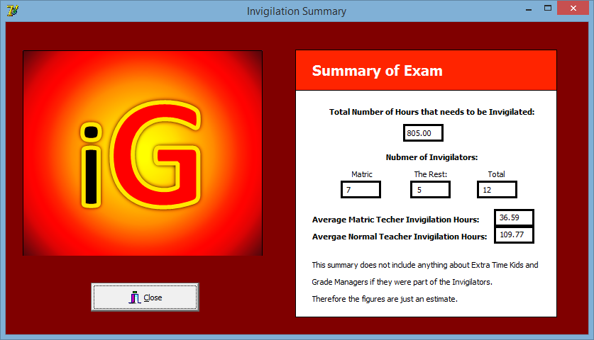
Description | Summary of Exam from inputted info.
Security Group | All users. Invigilator manager especially.
Data | None.
Actions | btnClose – closes summary form.

GUI screen: Output
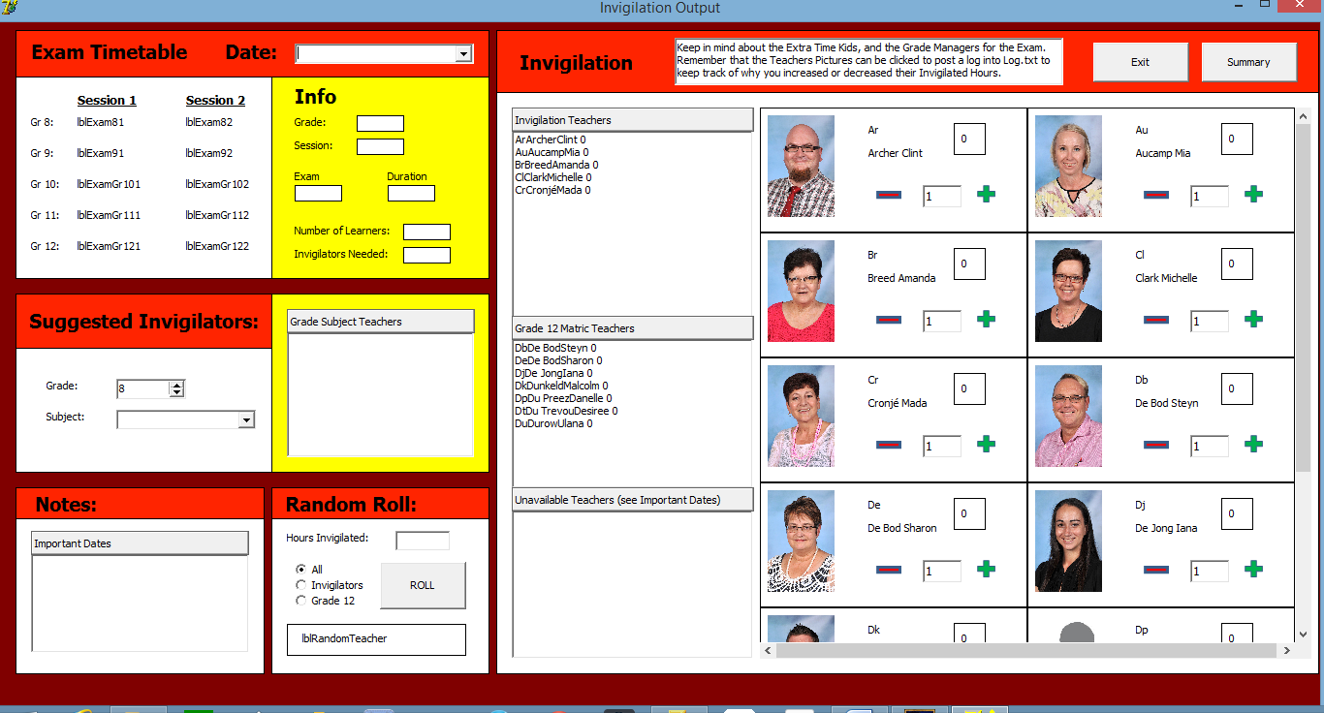
Description | Everything displayed that’s processed from input. Tools to help make Invigilation schedule.
Security Group | All users. Invigilator manager especially.
Data | Date – to get important dates and exam timetable on the day.
Actions | Adding or Subtracting images to add to invigilation hours invigilated.  Click on teacher pictures to post a log.  btnRoll – for a random teacher.  Select date shows all the subjects and papers written on that day.  Selecting a subject will show the suggested teachers who teach the subject of that grade.
2.2. Reports
No reports are generated as the application is to help an invigilator to make the invigilation schedule for the exam.

3. Business Layer

Sequencing
- Splash Screen
  - Wait for next menu screen to load.
- Menu
  - Welcome page to Invigilator.
  - Click btnBegin to begin the process.
- Input
  - There are 6 input files needed to be inputted.
  - Once all 6 files have been inputted and the boxes are green, user can proceed.
  - This input process needs to be done properly, as the better the input, the better the output.
  - Files that need to be inputted:
    - Staff List
    - Exam Timetable + Number of Learners per Subject
    - Important Dates
    - Teacher’s Pictures
    - Subject List
    - Grade Managers
- Summary
  - Displays to the invigilator some crucial information that have been calculated.
- Output
  - Select date to make an invigilation schedule for.
  - Select paper exam to which to allocate invigilators to in order to see more info.
  - Use the tools on the form to make the invigilation schedule.
  - Add the invigilated hours as you assign them slots.
  - Use Random Roll when stuck on which teacher to use.
  - Use suggested invigilators when stuck.
  - Enjoy till schedule has been complete.
4. Objects / Classes to be developed

Class Name: TTeacher
Purpose of class: Object teacher to have name, surname and code.
Fields
Field Name | Data type | Description
fCode | String | Code of teacher – 2 letter abbreviation
fName | String | Name of teacher.
fSurname | string | Surname of teacher.
Methods
Method name | Data type (if typed) / void | Description
Constructor create | Void | Creates an instance of the class.
Destructor destroy | Void | Free the class from memory.
Function gets | String | Accesses all the private variables.
Procedure sets | String | Changes the values of the private variables.
Function toString | String | Returns a string with all the teacher’s info.

Class Name: TMeeting
Purpose of class: An important meeting that is during the time of exam.
Fields
Field Name | Data type | Description
fDate | String | Date of meeting.
fEvent | String | Event description.
fTime | String | Time of meeting.
fArrTeachers | Array of TTeacher | Teachers attending this meeting.
fCount | Integer | Number of teachers attending meeting.
Methods
Method name | Data type (if typed) / void | Description
Constructor create | void | Creates an instance of meeting class.
Destructor destroy | Void | Free classes from memory.
Function gets | String | Accessors to private variables.
Procedure sets | String | Mutators to private variables.
Function toString | String | All the meetings info.
Procedure addTeacher | Void | Add Teacher attending meeting.
Procedure removeTeacher | Void | Remove teacher attending meeting.
Function getTeacher | TTeacher | Returns a specific teacher.

Class Name: TEvent
Purpose of class: Group up all the meetings during the exam into one class.
Fields
Field Name | Data type | Description
fCount | Integer | Number of meetings.
fArrMeetings | Array of TMeetings | The different meetings during the exam.
Methods
Method name | Data type (if typed) / void | Description
Constructor create | void | Creates an instance of this class.
Destructor destroy | Void | Frees class from memory.
Procedure addMeeting | Void | Adds a meeting to the class.
Function getMeeting | TMeeting | Returns a meeting.
Function allMeeting | String | Returns all the meetings on a specific date.

Class Name: TExam
Purpose of class: An object of an exam paper that any grade writes.
Fields
Field Name | Data type | Description
fDuration | String | Duration of paper.
fDate | String | Date of paper.
fExam | String | Papers subject and number.
fInvigilators | Integer | Number of Invigilators needed.
fLearners | integer | Number of learners writing this paper.
Methods
Method name | Data type (if typed) / void | Description
Constructor create | void | Creates an object of the class.
Destructor destroy | Void | Frees object from memory.
Function gets | String/integer | Returns a private variable.
Procedure sets | Void | Makes changes to a private variable.
Function toString | String | Returns the exam paper’s info.

Class Name: TGrade
Purpose of class: Each grades exams.
Fields
Field Name | Data type | Description
fCount1 | integer | Number of session 1 exams.
fCount2 | Integer | Number of session 2 exams.
fGrade | Integer | The grade writing these exam papers.
fArrS1Exam | Array of TExam | Exam info of all session 1 exams.
fArrS2Exam | Array of TExam | Exam info on all session 2 exams.
Methods
Method name | Data type (if typed) / void | Description
Constructor create | Void | Creates an instance of this class.
Destructor destroy | Void | Frees the instance from memory.
Function gets | String, integer, TExam | Returns specific but all private variables.
Procedure sets | Void | Changes the value of a private variable.
Procedure SessionCheck | Void | Adds all the exam in the session. Adds all the exam in the session. Normally has more than one exam. Normally has more than one exam.
Procedure addExam | Void | Adds exam info to either session 1 or session 2 exam.

Class Name: TTimetable
Purpose of class: The whole timetable of exam papers in their different grades.
Fields
Field Name | Data type | Description
fCount | integer | 5 grades in an exam.
fArrGrade | Array of TGrade | Array of grades with their exam papers.
Methods
Method name | Data type (if typed) / void | Description
Constructor create | Void | Creates an instance of this class.
Destructor destroy | Void | Frees object from memory.
Procedure addGrade | Void | Adds a grade with exam papers to this class.
Function getGrade | TGrade | Returns a TGrade with its whole exam schedule.
Function getCount | Integer | Returns the number of grades in class – 5.

Class Name: TSubjects
Purpose of class: Grade subject’s teachers – suggested invigilators.
Fields
Field Name | Data type | Description
fTeacherCount | Integer | Number of teachers that teachers this grade’s subject.
fSubject | String | Subject.
fArrTeachers | Array of TTeacher | Teachers involved in this subject.
Methods
Method name | Data type (if typed) / void | Description
Constructor create | Void | Creates an object of this class.
Destructor destroy | Void | Frees the object from memory.
Procedure addTeacher | Void | Adds a teacher to this subject.
Procedure removeTeacher | Void | Removes a teacher from the subject.
Function getTeacher | TTeacher | Returns a teacher’s info.

Class Name: THead
Purpose of class: Keeps all the subjects teachers together into one.
Fields
Field Name | Data type | Description
fSubjectCount | integer | Number of Subjects.
fGrade | integer | Grade with these subjects.
fArrSubjects | Array of TSubjects | All the subjects.
Methods
Method name | Data type (if typed) / void | Description
Constructor create | Void | Creates an instance of this class.
Destructor destroy | Void | Frees a class object from memory.
Function getGrade | integer | Gets the grade with these subjects.
Function getSubject | TSubject | Returns a subject.
Procedure addSubject | Void | Adds a subject to the grade.

Class Name: TInvigilators
Purpose of class: Gets all the invigilators of this exam.
Fields
Field Name | Data type | Description
fMatricCount | Integer | Number of matric teachers.
fInvigilatorCount | Integer | Number of non-matric but invigilating teachers.
fArrMatric | Array of TTeacher | Array of matric teachers.
fArrInvigilator | Array of TTeacher | Array of invigilating teachers.
Methods
Method name | Data type (if typed) / void | Description
Constructor create | Void | Creates an instance of this class.
Destructor destroy | Void | Frees an object of this class from memory.
Procedure addMatric | Void | Adds a matric teacher.
Procedure addInvigilator | Void | Adds an invigilator.
Procedure RefreshInvigilators | Void | Resets all invigilators to 0.

Class Name: TManagers
Purpose of class: Gets the data of the set managers.
Fields
Field Name | Data type | Description
fGrade8 | Array[1..2] of TTeacher | Grade 8 managers.
fGrade9 | Array[1..2] of TTeacher | Grade 9 managers.
fGrade10 | Array[1..2] of TTeacher | Grade 10 managers.
fGrade11 | Array[1..2] of TTeacher | Grade 11 managers.
fGrade12 | Array[1..2] of TTeacher | Grade 12 managers.
Methods
Method name | Data type (if typed) / void | Description
Constructor create | Void | Creates an instance of this class.
Destructor destroy | Void | Frees object from memory.
Procedure add8/9…12 | Void | Adds a manager to the specific grade.

Class Name: TPic
Purpose of class: Picture of teacher with their number of hours invigilated.
Fields
Field Name | Data type | Description
fPath | string | Teacher’s picture.
fTeacher | TTeacher | Teacher profile.
fHoursInvigilated | real | Hours they have currently invigilated.
Methods
Method name | Data type (if typed) / void | Description
Constructor create | Void | Creates an instance of this class.
Destructor destroy | Void | Frees object from memory.
Procedure setTeacher | Void | Sets the teacher’s profile.
Function gets | TTeacher, string, real | Returns private variables.
Procedure sets | String, real | Changes private variables.

Class Name: TPictures
Purpose of class: Class of teachers profiles with pictures and their hours invigilated.
Fields
Field Name | Data type | Description
fCount | Integer | Number of teachers.
fPath | String | Global folder path.
fArrPics | Array of TPic | The teacher’s profile with their pictures.
Methods
Method name | Data type (if typed) / void | Description
Constructor create | Void | Creates an instance of this class.
Destructor destroy | Void | Frees object from memory.
Procedure addPic | Void | Adds a teacher’s profile and their picture.
Procedure RefreshPic | Void | Resets all Pictures.

Class Name: TTeach
Purpose of class: Subject class that groups all different grade subjects together.
Fields
Field Name | Data type | Description
fArrHeads | Array[1..5] of THead | Grades with their subjects and teachers.
Methods
Method name | Data type (if typed) / void | Description
Constructor create | Void | Creates an instance of this class.
Destructor destroy | Void | Frees object from memory.
Function getHead | THead | Returns a grade’s subjects and their taught teachers.

5. Database Layer
No databases was used.
Excel files were used to get data from.
A Log.txt textfile was used to keep track of events.

The following Excel files are needed:
- Input Folder:
  - Exam June 2015.xlsx
  - Extra Time Learners 2015.xlsx
  - Important Dates 2015.xlsx
  - Staff 2015.xlsx
  - Subjects 2015.xlsx
  - Totals for subjects 2015.xlsx
In addition this file contains extra files:
  - The Staff Pictures folder
  - Extra Time Kids Note.txt textfile

Explanation of data storage
A sort of database table was needed for all this data. I could have used Excel or Access, but Access had a more free environment in working then access and so the files were easier to create in access. It is also easier to see data in Excel than in Access. Excel is great for tables and all this data were best fit for in the form of tables. Excel gave the user a clear view of what was going on and data in a table can be used to compare and for transparency.

